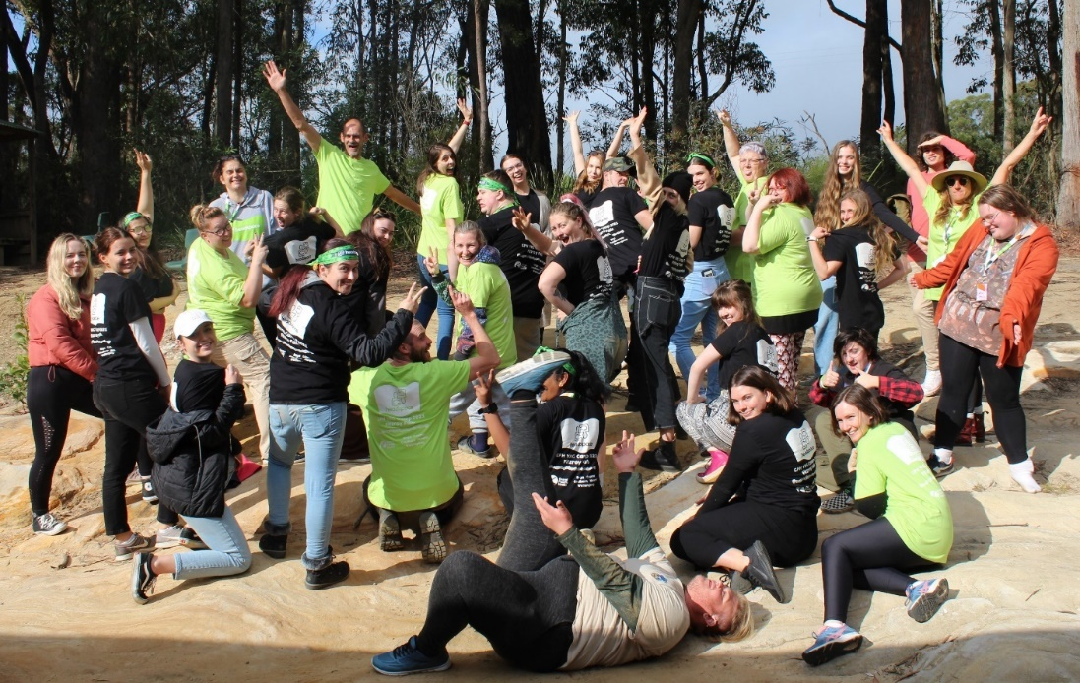

headspace Wollongong Youth Reference Group
Application Package 2022

headspace Wollongong provides young people with the opportunity to be heard, and to offer input and feedback on both our service, and community approaches to youth mental health more broadly.
Youth Reference Group members do vital work to keep our service running, including:
- Providing feedback on headspace Wollongong services and programs, including cultural safety
- Offering insight around how young people experience and navigate support services, including headspace Wollongong
- Suggesting, and helping to implement, programs and events
- Giving feedback about local youth and health services

By getting involved you will:

- Accessing training and development opportunities
- Have the opportunity to have your say on headspace Wollongong’s services and programs
- Develop new skills
- Meet and work with other young people who are passionate about youth mental health
- Make a difference to youth mental health in your community.

The Youth Reference Group meets fortnightly on a Thursday afternoon at headspace Wollongong, and also provides regular feedback and input through an online forum. We take our volunteers away to a weekend camp every year also, for valuable training and sharing opportunities with other young people across South Eastern NSW and ACT.

Who can apply?

We are looking for anyone aged between 16 and 25 who is interested in promoting youth mental health and wellbeing in the Wollongong area.

We want you to apply if:

- You have lived experience of mental ill-health or mental health variation (this could be your personal experience, work experience, or experience of someone you know or care for)

- You feel passionate about and are interested in mental health issues and young people’s health and wellbeing in our community.

- headspace Wollongong is also keen to hear the voices of Aboriginal and Torres Strait Islander young people, young people from different cultural and language backgrounds, young parents, young people from rural and remote areas, young people of diverse sexualities and genders, and young people who have been homeless.

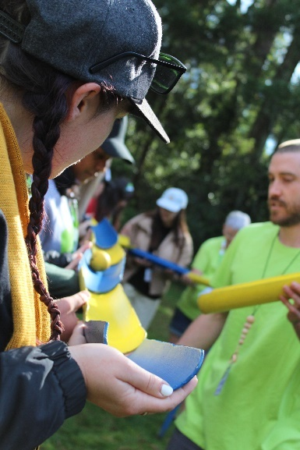

Youth Reference Group Application Form

Name:

Date of Birth:

Phone number:

Email address:

What is your cultural background (For example, Aboriginal and Torres Strait Islander, Arab-Australian, Anglo-Australian, Syrian, Indonesian)?

What languages do you and/or your family speak at home?

Do you identify as Aboriginal and/or Torres Strait Islander?

Neither/Aboriginal/Torres Strait Islander/Both

What’s your gender identity?

Is there anything else you would like to share with us about your identity?

About You

These questions are your opportunity to tell us a bit about you, and help us decide your suitability for the Youth Reference Group:

Please tell us a bit about yourself:

(For example: I am 16 years old, and attend alternative education centre 3 days a week, I like skate-boarding etc)

What does mental health and wellbeing mean to you?

Why do you think it is important to improve young people's access to health services?

Are you involved in any other organisations or volunteering?
If yes, which ones and what is your involvement?

Do you have any accessibility requirements, dietary requirements, or anything else you would like to share that would help us to support your involvement?

About the Youth Reference Group

Why you are interested in becoming a Youth Reference Group member at headspace Wollongong?

What skills and ideas could you bring to the Youth Reference Group?

Thanks for applying to be a part of the headspace Wollongong Youth Reference Group.
Please be aware places are limited and there is a selection process. Successful applicants will be appointed as volunteer employees of Grand Pacific Health and will be covered by Grand Pacific Health staff policies and expected to adhere to Grand Pacific Health Policies and Procedures.
Volunteers over the age of 18 will require a volunteer NSW Working with Children Check.
It is a condition of engagement that volunteers for headspace Wollongong be double vaccinated against COVID-19.
If you have any questions, or if you don't hear back from us, please don't hesitate to get in touch and drop us a line. You can contact Meghan, our Community Engagement Officer, on 4220 7660 or mokeefe@gph.org.au.

To complete your application please fill out and send this form to headspace@gph.org.au or PO Box 6038, Wollongong NSW 2500.

