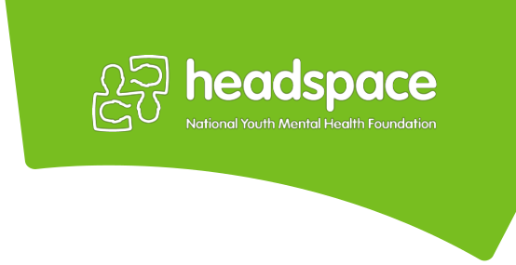
Service Provider Referral form

Referral to headspace services

(please select one and forward to nearest centre)

Mt Druitt

55 North Parade, Mount Druitt, 2770
Phone: 1800 683 784
Fax: (02) 4720 8899

Email:

headspacemtdruitt@parramattamission.org .au

Parramatta
(for headspace Early Psychosis referrals only, for Primary Care referrals please click here)

2 Wentworth St, Parramatta, NSW,
2150

Phone: 1300 737 616 Fax: (02) 8331 6056 Email:

headspace.parramatta@flourishaustralia.org.au

Penrith

606 High St, Penrith, NSW, 2750
Phone: 1800 477 626
Fax: (02) 4720 8844
Email:
headspacepenrith@parramattamission.org. au

Important information regarding your referral, please read:

- headspace is a service for young people between the ages of 12 to 25. We can only engage with young people who have provided consent to the referral. N.B. If the young person is unable to provide informed consent due to mental state (e.g. psychosis), please contact us.

- If the young person is at high or acute risk of suicide, please contact emergency services on 000.

- Please note that receipt of the referral form does not indicate acceptance to the headspace services. Suitability of the referral will be determined following assessment with the young person. Please contact the relevant headspace site to confirm receipt and discuss the outcome of your referral.

- To assist with the referral, please attach any relevant assessment notes, discharge summaries and/or additional information. We will endeavour to respond to referrals within 24 – 48 hours business hours. If you have any queries pertaining to your referral, please call the relevant site using the contact details above.
Consent for referral: If the young person is unable to provide informed consent due to mental state (e.g.
psychosis), please contact us.

Has the young person consented to and provided permission to exchange | Yes | No
information in relation to this referral?

Primary reason(s) for referral: This section must be completed. Please contact us for queries regarding services available.

Short-term Mental Health Intervention with headspace Primary Care Team

Does the YP have a Mental Health Care Plan? Yes No

Assessment with headspace Early Psychosis

Drug and Alcohol Support Vocational Support

Physical Health Support

Page 1 of 4

Referrer details: We will be corresponding with you using the below details. Please ensure that all details listed below are current.

Name of Referrer: |  | Organisation:
Relationship to Young
Person: |  | Designation:
Contact Number: |  | Fax:
Service Address:
Email:

Parent/guardian details: * please note that if the Young person is aged 15 and under, we will require a parent or guardian to be documented on this form.

Name:

Relationship to young |  |  | Contact
person: |  |  | Number:
Do we have permission to speak with the young
person identified? |  | Yes | No

 | Young Person’s details:
 | Name:
 | Date of Birth: |  |  |  | Age: |  |  |  |  |  | Gender:
 | Address:
 | Suburb: |  |  |  |  |  |  |  |  |  | Postcode:
 | Contact Number 1: |  |  | 2.
 | Medicare Card
 | Details: |  |  |  |  |  |  | Expiry Date:
 | Interpreter Required?Yes, Language: |  |  |  |  |  |  | No
 | Assistance with
 |  | Yes |  |  |  |  |  | No
 | Reading/Writing?

headspace National Youth Mental Health Foundation is funded by the Australian Government Department of Health Page 2 of 4

Presenting Issues:

Current presenting issues (please include duration, age of onset, and any relevant pre-existing diagnoses):

Impact of problem on functioning: (e.g. relationships/school/home/work)
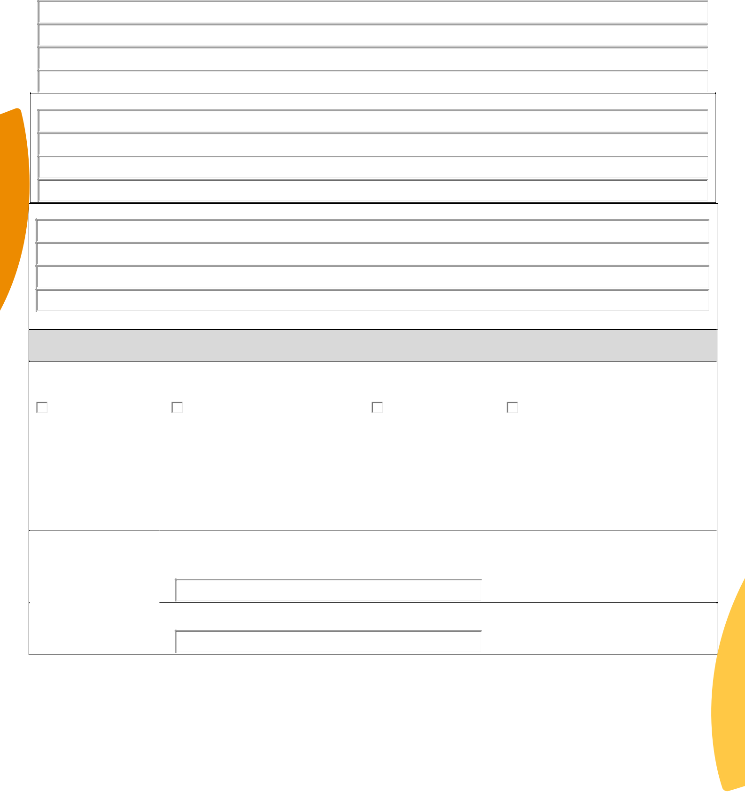

Please indicate if there is any known family history of mental health conditions:

Previous/current engagement with headspace or other services:

Risk Factors:

Suicide

Non-accidental self-injury

Harm to others

Extreme social withdrawal

Homelessness | Substance use | Accidental Death | Non-compliance
Details:

Referrer’s

Signature:

By signing this document, the referrer agrees that the above information is accurate and current to their knowledge

Date:

headspace National Youth Mental Health Foundation is funded by the Australian Government Department of Health Page 3 of 4

Office Use Only

Plan (to be reviewed at intake meeting): When booking appointment, please request that the young person attends 15 minutes prior to their appointment time

□ Book with YAT Clinician | Date/Time: ________________________ | Clinician:
 | ___________________
□ Joint YAT/MATT Consultation | Date/Time: ________________________ | Clinician:
 | ___________________
□ Direct Allocation to CCT | Date/Time: ________________________ | Clinician:
 | ___________________
□ MATT Assessment

- Referral to Co-located LHD Team

- Declined/Referred Elsewhere

Date/Time: ________________________ Clinician(s):
_________________

Recommendations Made:

_________________________________________

If you need to speak to someone
If you need to speak to someone urgently, please call Lifeline on 13 11 14 or Kids helpline
1800 55 1800.
If you need immediate support, call 000.
You can also get help in person at a headspace centre located near you or via our online support service at eheadspace. Visit:
headspace.org.au/headspace-centres/ headspace.org.au/eheadspace/.
headspace National Youth Mental Health Foundation is funded by the Australian Government Department of Health.
urgently, please call Lifeline on
13 11 14, Kids helpline
1800 55 1800 or the NSW Mental
Health Line 1800 011 511.
If you need immediate support,
call 000.

headspace National Youth Mental Health Foundation is funded by the Australian Government Department of Health .

