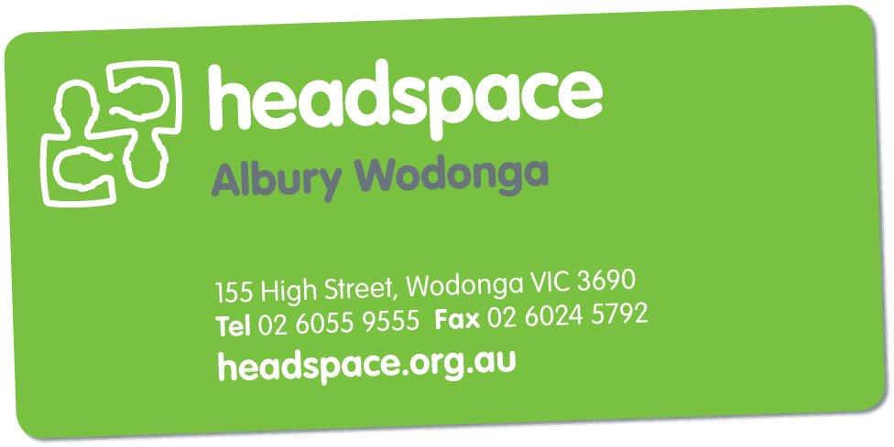

Applications are now open for the:
headspace Youth Reference Group

Are you aged between 16 and 25 and live in the Albury Wodonga region? Do you have something to say about health, mental health, education and employment and drug and alcohol issues?
What is the headspace Youth Reference Group (YRG)?

headspace provides young people with the opportunity to be heard and be active around youth mental health issues.
There are a number of roles you can play in a headspace local reference group, including:
- Developing and organising projects and events in our local area
- Consultation and evaluation of headspace services, policies and resources
- Being a media spokesperson
- Undertaking training and education opportunities in relation to headspace matters

By getting involved you will:
- Have the opportunity to have your say and direct youth mental health services in the Albury Wodonga region
- Develop new skills
- Meet and work with other young people who are passionate about youth mental health
- Make a difference to youth mental health.

headspace will provide some training to support you to participate in the above groups or activities.

How do I get involved?

Please complete the application form and email it to:

bree.cross@gatewayhealth.org.au
or you can post or drop it in to:

headspace Albury Wodonga
155 High Street
WODONGA VIC 3690

2020 Info Session date to be confirmed
Applications close Friday 28 February 2020

Who can apply?
Anyone aged between 16 and 25 who is involved with their local headspace centre or wants to create positive change in our community

We want you to apply if:

You have knowledge of, interest in and feel passionate about mental health issues.

The Youth Reference Group is also keen to hear the voices of Aboriginal and Torres Strait Islander young people, young people from culturally diverse backgrounds, young people from rural and remote areas, gay, lesbian, bisexual and transgender young people and young people who have been homeless.

headspace YRG application form
Personal Details

Name
Phone
Email
Address

Date of Birth
Pronoun
she/her he/him they/them

What languages do you speak at home?

Where were you born?

Are you Aboriginal or Torres Strait Islander?

Where do you live? (suburb)

Do you identify as having/had a mental health barriers?

Is this something that you would be happy (and feel comfortable) talking about?

About You

Please tell us a bit about yourself.
(For example: I am 16 years old, and attend alternative education centre 3 days a week, I like skate-boarding etc.)

Why do you want to be involved in headspace?

Please describe why you are interested in becoming a Youth Reference Group member.

What type of headspace activities would you like to be involved in?

What skills and ideas could you bring to the Youth Reference Group?

Are you involved in any other organisations? If yes, which ones and what is your involvement?

