What’s the app? | What does it do?
Beyond Now

A suicide safety planning app that assist you to create your own suicide safety plan; a plan to keep you safe when you are experiencing suicidal thoughts. Create a list of ideas, contacts, warning signs, coping strategies and reasons to live that support you.
Sayana

Sayana is a self-discovery bot that will help you understand yourself better and unpack your thoughts and emotions. Chat abut school, work, relationships and anything ese. Sayana will help guide you through everyday practice of acknowledging, understanding and mindfully accepting your life.

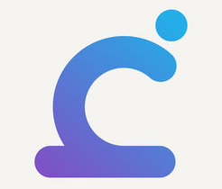  FREE APPS TO CHECK OUT ON THE APP STORE OR GOOGLE PLAY  FREE APPS TO CHECK OUT ON THE APP STORE OR GOOGLE PLAY | Calm Harm  Provides tasks that help you resist or manage the urge to self harm. Assists with developing distraction and learn new ways to comfort yourself and express feelings in a different way. Completely private and password protected.
BeyondBlue Check-in

An app designed to help you check-in with a friend you are concerned about with handy conversation tools. Helps you plan how to approach the person you care about, what you will say and how you will offer support.

Smiling Mind

Smiling Mind is a mindfulness meditation app to help bring balance to your life. Assists with dealing with pressure, stress and challenges of daily life and learn relaxation strategies.

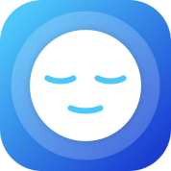 | MindShift  Mindshift will help you learn how to relax, develop more helpful ways of thinking and identify active steps that will help you take charge of your anxiety. Helps develop tools to tackle worry, panic, perfectionism, social anxiety and phobias.
ReachOut WorryTime

The WorryTime app allows you to control everyday stress and anxiety by acting as a place to store your daily worries so you don’t get caught in them.
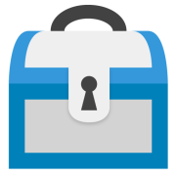 | MoodTools  If you are feeling sad, down, anxious or depressed, lift your mood with MoodTools. Designed to help you combat depression and get rid of negative moods. The app has thought diaries, activities, safety plan, information and tests.
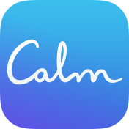 | Calm  Calm is a mindfulness app for beginners that aims at improving sleep, lowering stress and less anxiety through guided meditations, sleep stories, stretching exercises, breathing programs and relaxing music.
What’s Up?

App that utilises CBT (Cognitive Behavioural Therapy) and ACT (Acceptance and Commitment Therapy) methods that help you cope with depression, anxiety, anger, stress and more!

SAM

Self-help for anxiety management. Users are encouraged to build their own anxiety toolkit that they find helpful and to use to manage their anxiety.
Moodpath

Is a personalised mental health companion. Track and reflect through a mood journal, assess your mental health and improve your understanding and learn new strategies.
Relax Melodies

Assists with improving sleep through guided exercises and programs designed to bring you a more peaceful sleep. A wide range of sound effects, white noise and melodies that help encourage sleep, meditation, yoga and relaxation.
ReachOut Breathe

Breathe helps you reduce the physical symptoms of stress and anxiety by slowing down your breathing and heart rate. Allows you to measure your heart rate in real time using the camera.
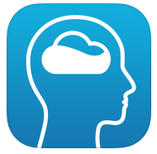 | Recharge Sleep  A personalised six week program focused on improving mood, energy and wellbeing by helping you to establish a good sleep/wake routine.

